PERSONAL INFORMATION | Vincenzo VENERITO
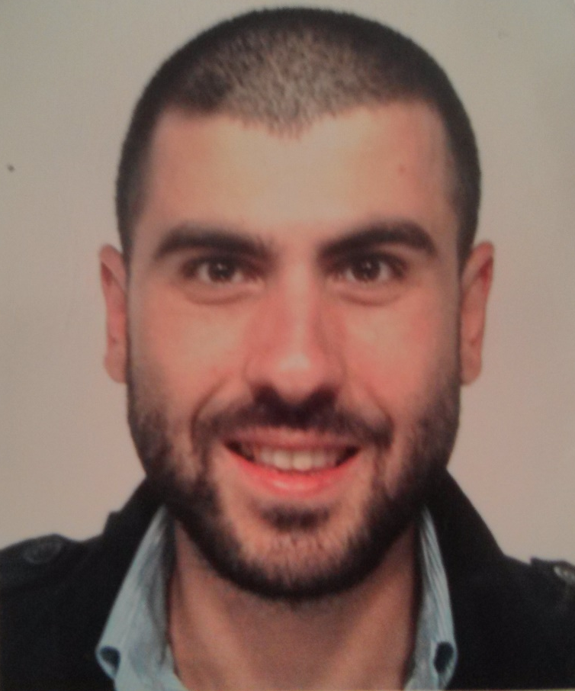 |   Via Ettore Carafa 51, 70124 Bari, Italy  Rheumatology Unit, Policlinico Hospital, Piazza Giulio Cesare 11, 70124 Bari, Italy

+390805564498  +393396648926

vincenzo.venerito@gmail.com
 | Sex Male| Date of birth 06/06/1988 | Nationality Italian

WORK EXPERIENCE

from November 2015 | MD Resident in Rheumatology
  March 2015 to October 2015 | Resident in Rheumatology
  March 2015 to October 2015 | University of Bari “Aldo Moro”, Shool of Medicine, School of Rheumatology
University of Bari “Aldo Moro”, School of Medicine, School of Rheumatology

Medical Consultant for GISEA Observatory
Epidemiologic Observatory GISEA, Italy

EDUCATION AND TRAINING

Specialized Certificate in Biostatistics
July 2017- March 2018 University of California, San Diego, USA
MD license
University of Bari “Aldo Moro”, Bari, Italy
February 2015

October 2008 to July 2014  September 2002 to July 2007 | Graduation in Medicine
October 2008 to July 2014  September 2002 to July 2007 | University of Bari “Aldo Moro”, Bari, Italy  Top Grade cum laude.
October 2008 to July 2014  September 2002 to July 2007 | High School Diploma – Classical Study  Tito Livio Classical High School, Martina Franca, Taranto, Italy  op Grade cum laude.

PERSONAL SKILLS

Mother tongue(s) | ITALIAN
Other language(s) | UNDERSTANDING |  | SPEAKING |  | WRITING
Other language(s) | Listening | Reading | Spoken interaction | Spoken production
ENGLISH | C1 | C1 | C1 | C1 | C1
 | Cambridge Advanced English, C1 level, July 2016

Other Skills

Office (Win/Mac)
Epidemiology
SAS
SPSS statistics
Stata
Western Blot
Flow cytometry
Muscoloskeletal US
Intra-articular Injections
Ultrasound Guided Synovial Biopsy
Photography

ADDITIONAL INFORMATION

Publications  Presentations  Honours and awards  Memberships  Courses  Certifications | - Lopalco G, Lucherini OM, Lopalco A, Venerito V, Fabiani C, Frediani B, Galeazzi M, Lapadula G, Cantarini L, Iannone F (2017) Cytokine Signatures in Mucocutaneous and Ocular Behçet’s Disease. Frontiers in Immunology 8 (200).  - Lopalco G, Rigante D, Venerito V, Fabiani C, Franceschini R, Barone M, Lapadula G, Galeazzi M, Frediani B, Iannone F, Cantarini L. Update on the Medical Management of Gastrointestinal Behçet's Disease. Mediators Inflamm. 2017; 2017:1460491.  - Venerito V, Lopalco G, Lucherini OM, Cantarini L, Lopalco A, Vitale A, Fornaro M, Lapadula G, Iannone F. Serum Amyloid A Stimulated Production of Pro-Inflammatory Cytokines by Peripheral Blood Monocytes in Patients With Behçet’s Diseaseposter Presentations: Basic Science. Clin Exp Rheumatol. 2016 Sep-Oct;34(6 Suppl 102):150-154.  - Lopalco G, Rigante D, Venerito V, Emmi G, Anelli MG, Lapadula G, Iannone F,, Cantarini L. Management of Small Vessel Vasculitides. Curr Rheumatol Rep. 2016 Jun;18(6):36.  - Perniola S, Natuzzi D, Lacarpia N, Bizzoca R, Venerito V, Moretti B, Notarnicola A, Maccagnano G, Lapadula G, Iannone F. Regulation of the expression of RUNX2 in human osteoarthritis osteoblasts with SP, IGF-1 and TNF-ALPHA: an in vitro study. Ann Rheum Dis 015;74(Suppl2):926.  - Venerito V, Lopalco G, Cantarini L, Guerriero S, Favale R, Nacucchi A , Rotondo C , Fornaro M, Rigante D, Galeazzi M, , Lapadula G, Iannone F. Epidemiology and Clinical Presentation of Ocular Involvement in a Population of 299 Patients with Non Infectious Uveitis. 53rd National Conference of the Italian Society of Rheumatology (SIR), Rimini, November 2016.  - Venerito V, Lopalco G, Lucherini OM, Cantarini L, Lopalco A, Vitale A, Fornaro M, Lapadula G, Iannone F. Serum Amyloid A stimulated production of proinflammatory cytokines by peripheral blood monocytes in patients with Behçet’s Disease.17th International Conference ob Behçet’s Disease, Matera, September 2016.  - “Verso Eular 2017” bursary provided by the Italian Society of Rheumatology (SIR) to young researchers for best presentation at the 53rd National Conference of the Italian Society of Rheumatology (SIR, Rimini, November 2016.  - Grant provided by the Italian Society of Rheumatology (SIR) to young researchers for best poster presented at the 17th International Conference on Behçet’s Disease, Matera, September 2016.  - Selected Visiting Student at Louise Coote Lupus Unit, St.Thomas’ Hospital, King’s College London, October 2013  - Italian Society of Rheumatology (SIR)  - EMEUNET  - Intra-articular Injection Course EdiAcademy, October 2015  - Muscoloskeletal Ultrasound Course, EMS school , Professor G. Monetti, November 2014  - Introductory Musculoskeletal Ultrasound Course, EULAR online, 2014  - Cambridge Advanced English, C1 Level, July 2016

